

**M. Tech. in Software Engineering**

**Cyber Security**

**SEZG681**

**Assignment 2 – Local DNS Attack**

**Name – Hemant Tiwari**

**BITS Student ID – 2022MT93184**

**Semester – 1st FY 2023-202**

**Setting Up Lab in Oracle VM Box**

To create a new VM in Oracle Virtual Box (VB), I followed the following steps:

**Step 1 –** Download the VM Image from [Seed Lab Website](https://seedsecuritylabs.org/Labs_20.04/Networking/Sniffing_Spoofing/).

**Step 2 –** In the VB, select new.

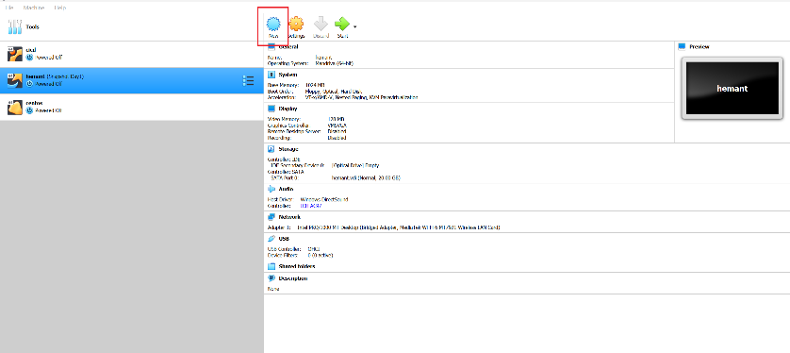

**Step 3 –** Provide the *Name*, *Memory Size* and *Hard Disk* of your Virtual Machine.

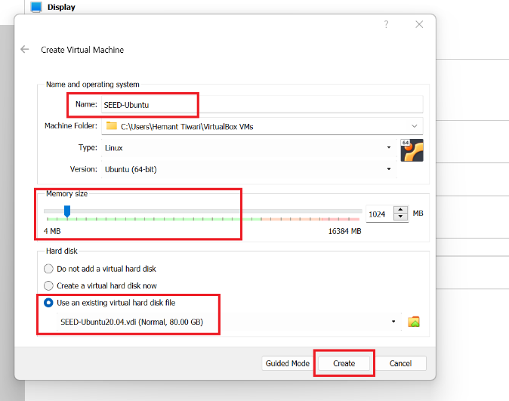

**Step 4 –** To use the downloaded Hard Disk, select “Use an existing Virtual Hard Disk File”. In that, click on add and choose your downloaded VM. Then click on create as shown in previous Image.

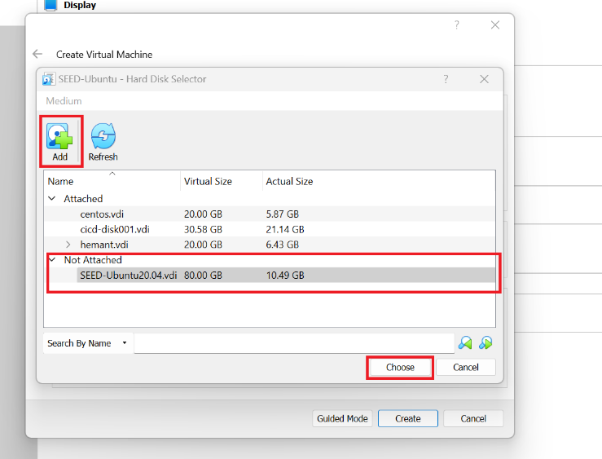

**Step 5 –** Once our VM is created we will select on the settings option of the VM.

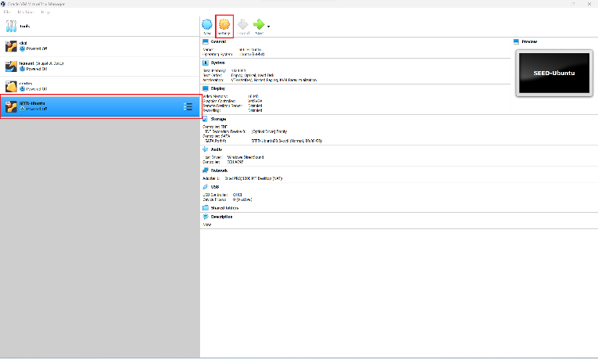

**Step 6 –** We will first go into General Setting >> Advanced and select *Shared Clipboard* and *Drag’n’Drop* as *BiDirectional*. The first item allows users to copy and paste between the VM and the host computer. The second item allows users to transfer files between the VM and the host computer using Drag’n’Drop.

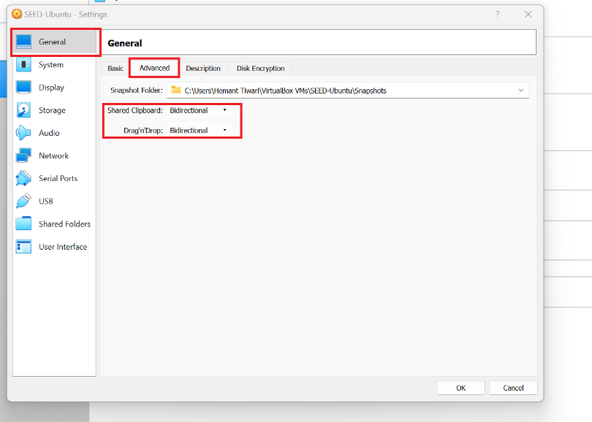

**Step 7 –** Than System >> Processor and define Processor(s) as 2 CPU and in Extended Features, Enable PAE/NX.

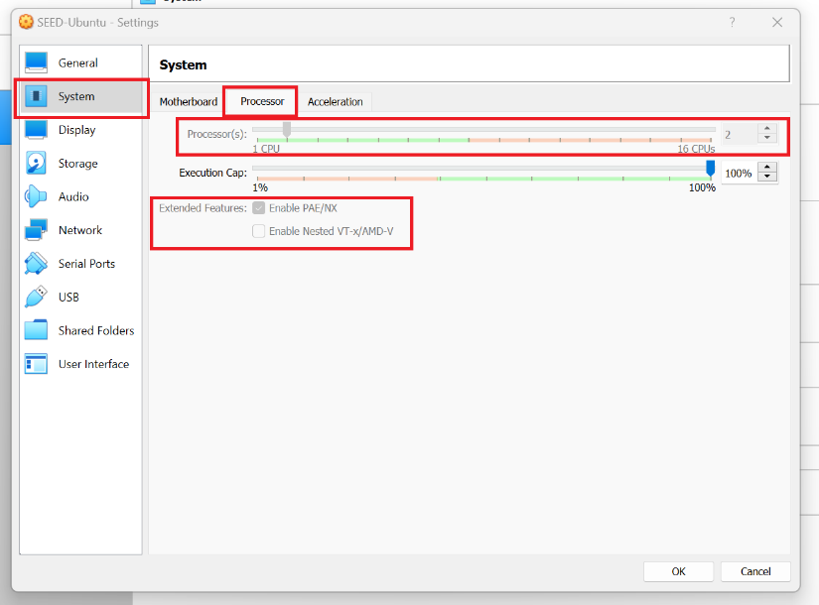

**Step 8 –** Than Display >> Screen. Here, select appropriate *Video Memory*. Select *VMSVGA* in *Graphics Controller* and *Enable 3D Acceleration*.

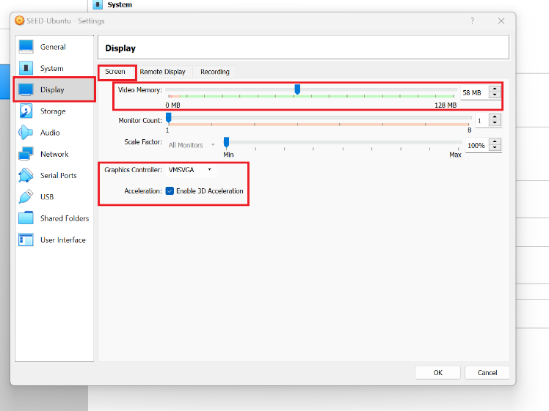

**Step 9 –** Than Network >> Adapter 1. In this select *Attached to* as *NAT* and Click on OK.

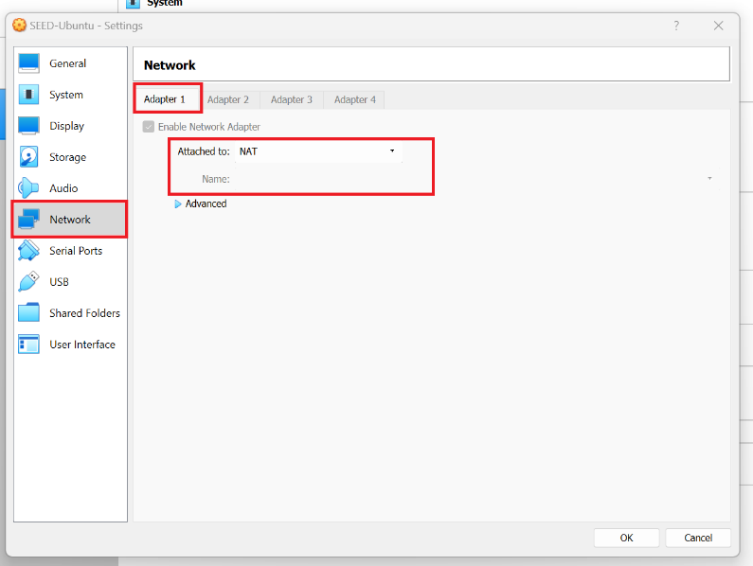

**Step 10 –** Once All the Configuration is done, we can start our VM by selecting on Start.

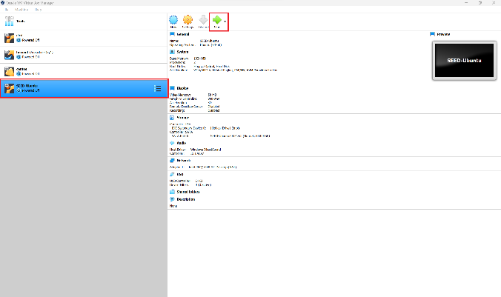 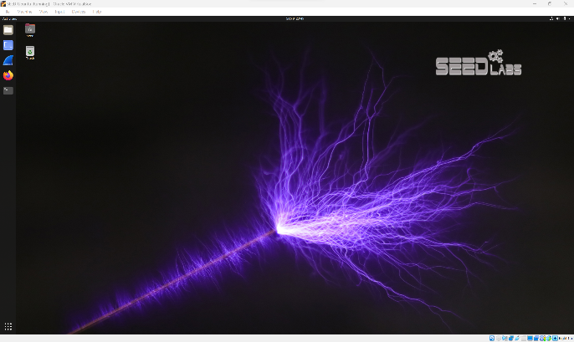

**Setting Up Docker Containers inside the VM**

Download the [Labsetup.zip](https://seedsecuritylabs.org/Labs_20.04/Files/DNS_Local/DNS_Local.pdf) file in the VM from the lab’s website, unzip it, enter the Lab setup folder, and use the docker-compose.yml file to set up the lab environment.

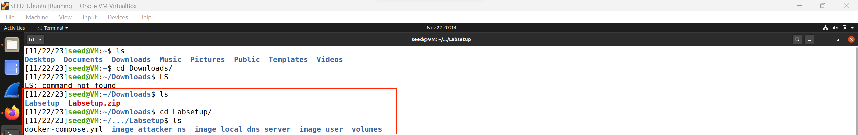

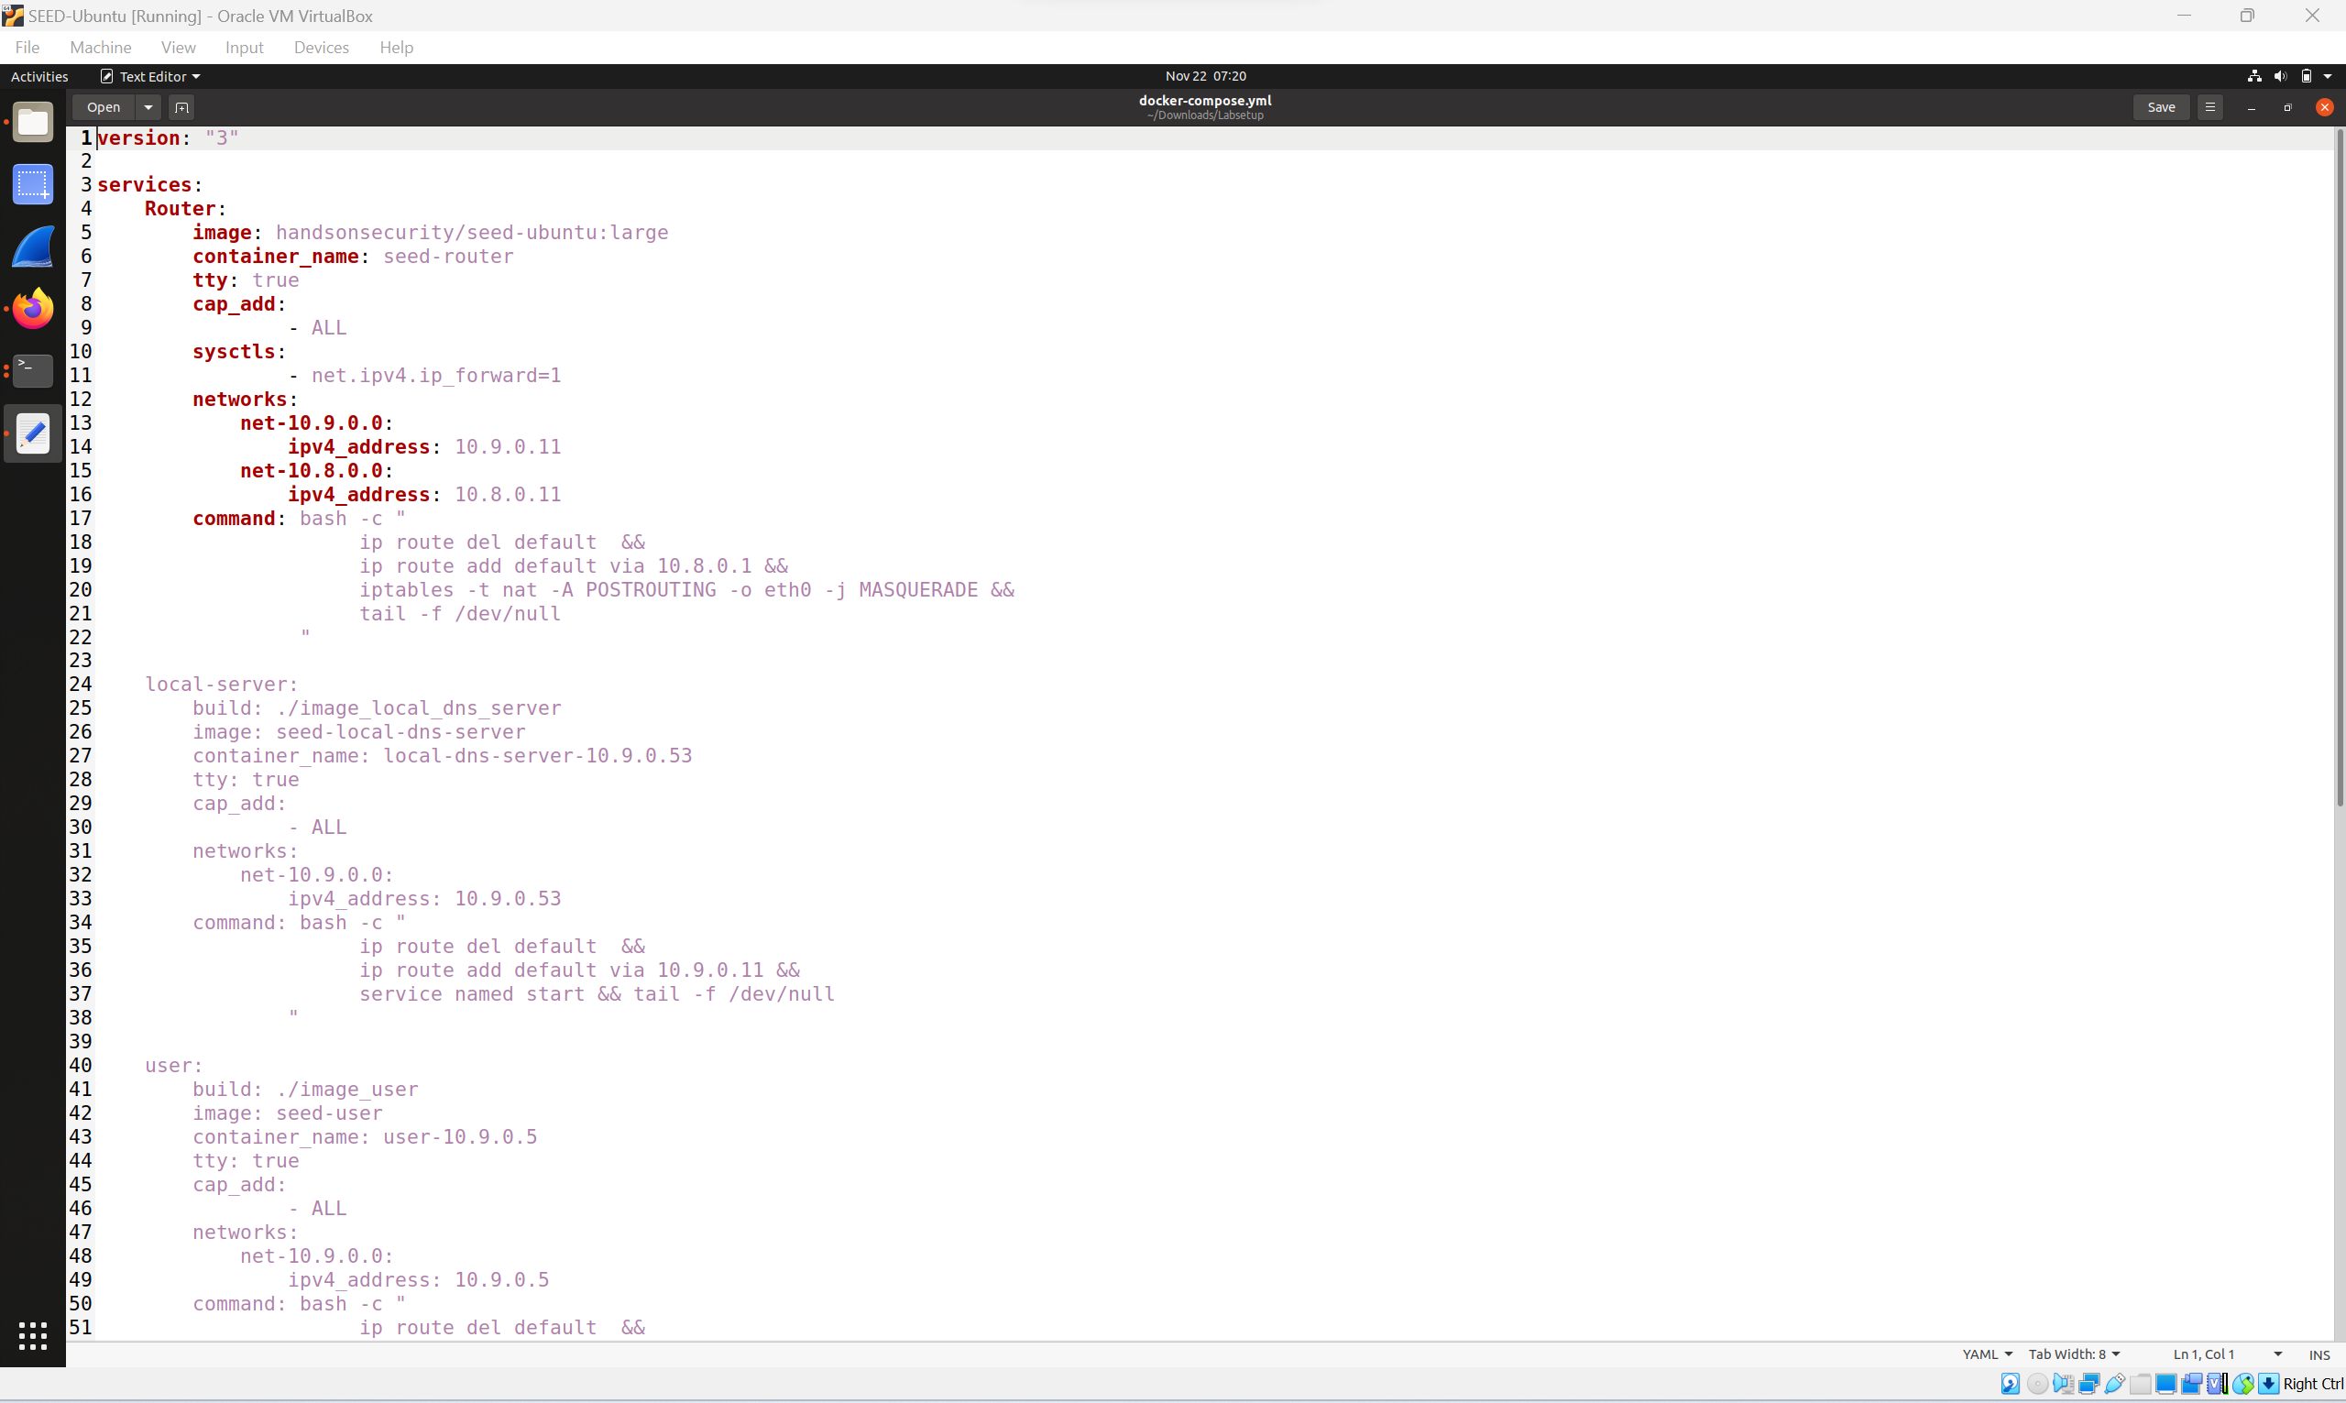

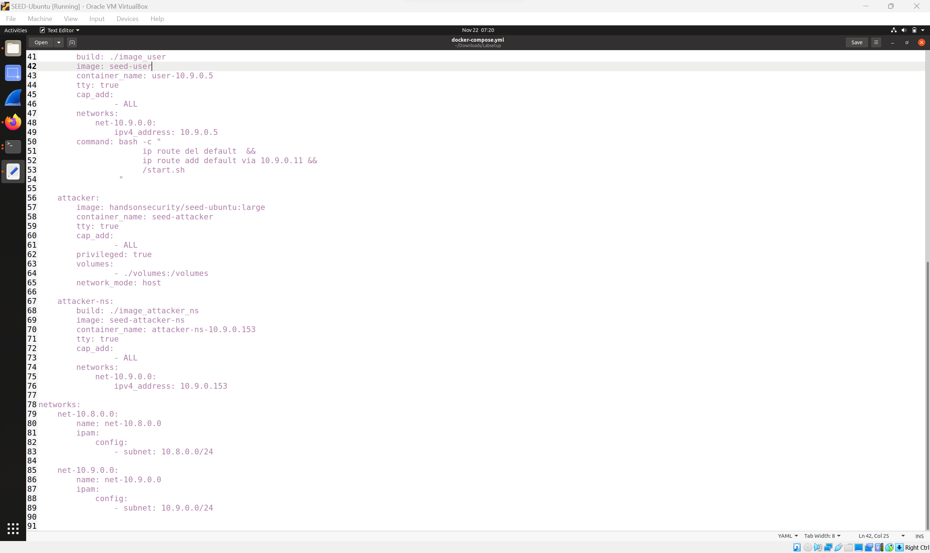

Post downloading run the command **dcbuild**

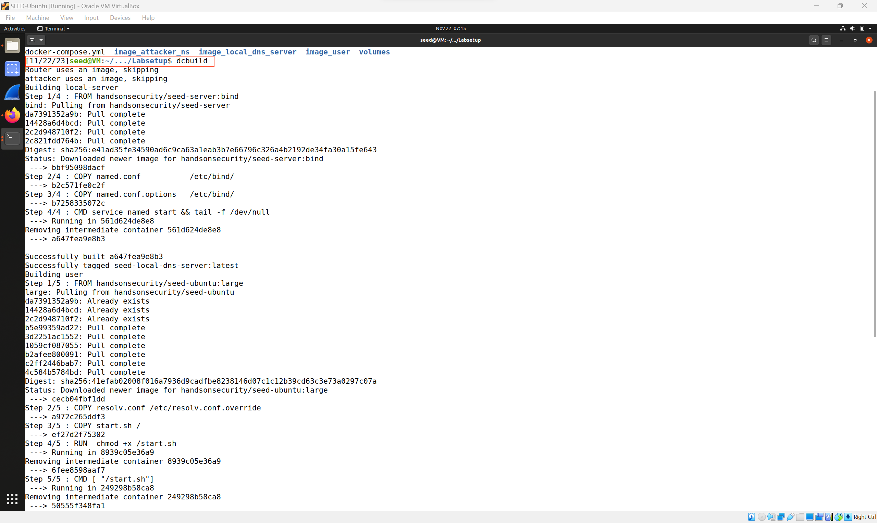

Once it is complete we can see the image and run the command dcup to spin up the container and we can see the containers.

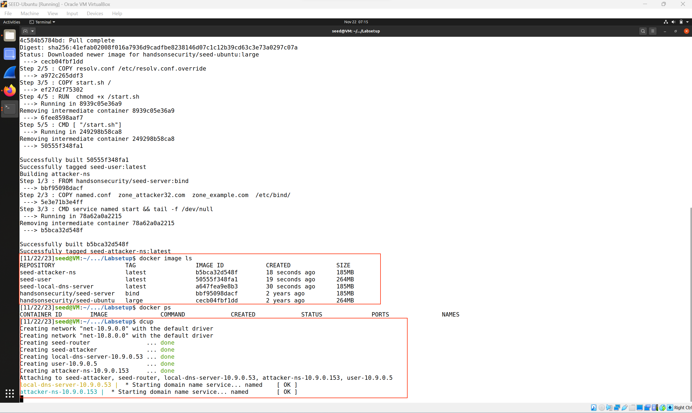

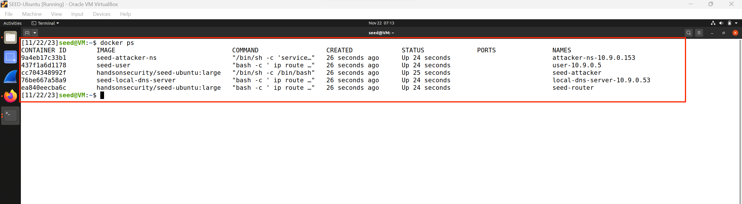

Once the containers are up setup will look like this –

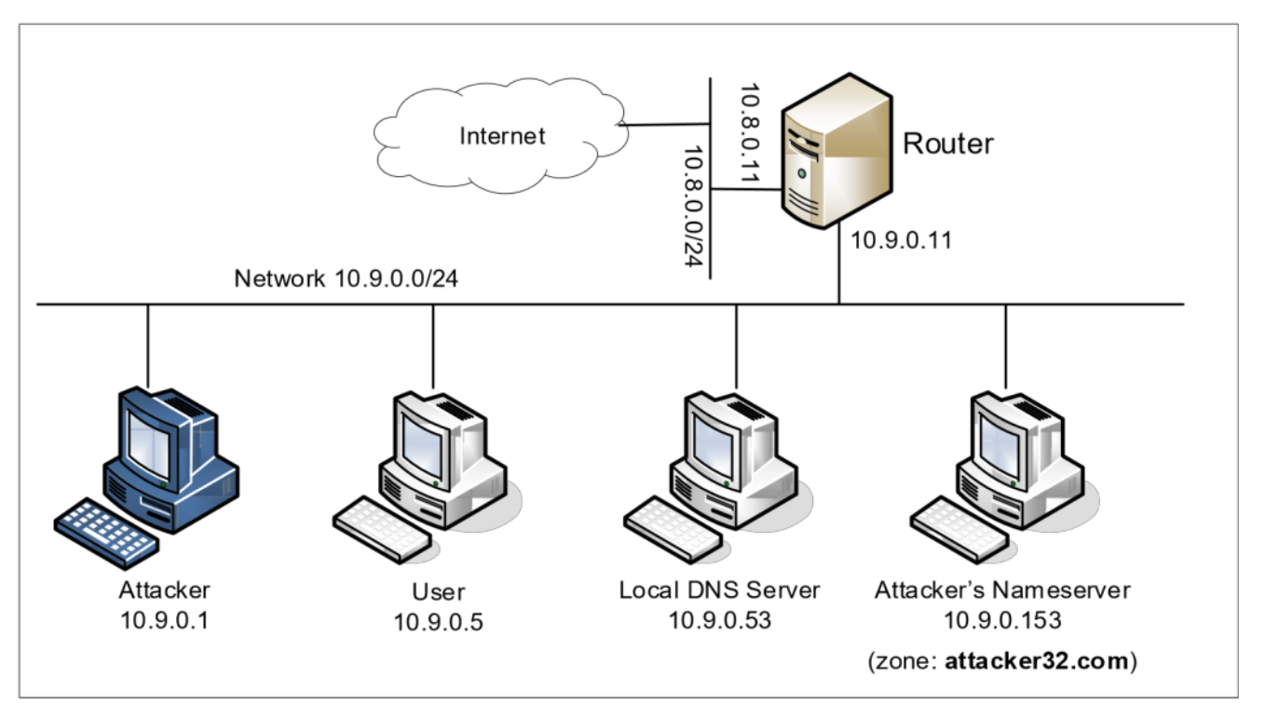

**Summary of the DNS Configuration**

The Volume folder of attacker folder is –

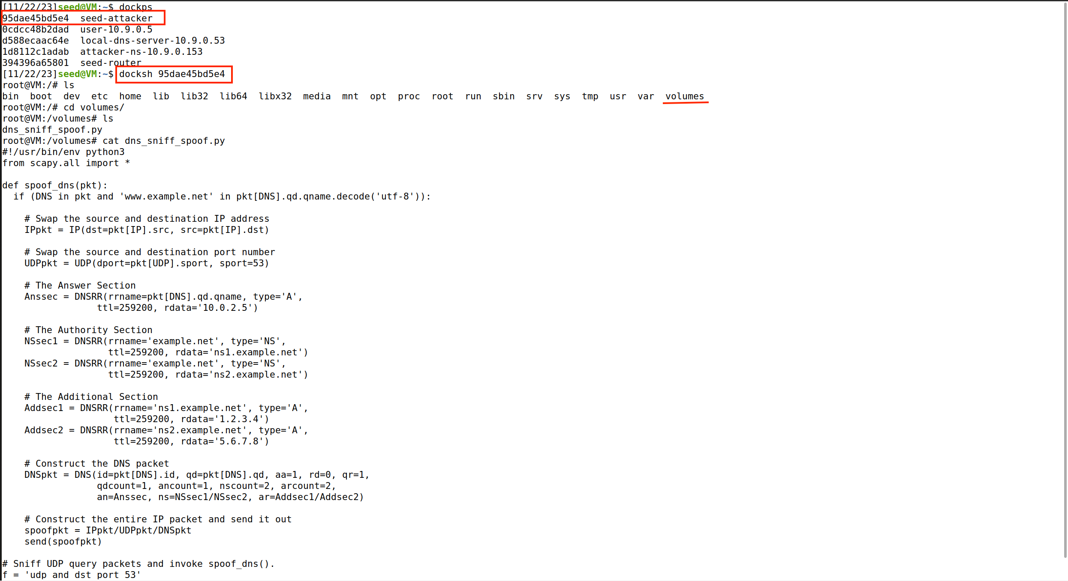

**Local DNS Server:** We run the BIND 9 DNS server program on the local DNS server. BIND 9 gets its configuration from a file called /etc/bind/named.conf. This file is the primary configuration file, and it usually contains several "include" entries, i.e., the actual configurations are stored in those included files.

One of the included files is called /etc/bind/named.conf.options. This is where the actual configuration is set.

**Forwarding the attacker32.com zone:** A forward zone is added to the local DNS server, so if anybody queries the attacker32.com domain, the query will be forwarded to this domain’s nameserver, which is hosted in the attacker container. The zone entry is put inside the named.conf file.

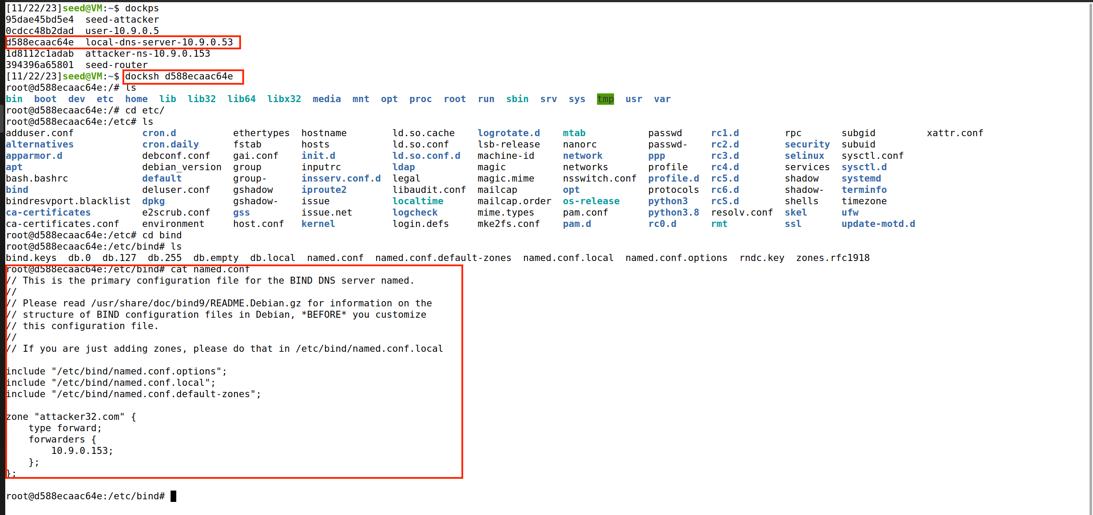

**Simplification:** DNS servers now randomize the source port number in their DNS queries; this makes the attacks much more difficult. Unfortunately, many DNS servers still use predictable source port number. For the sake of simplicity in this lab, we fix the source port number to 33333 in the configuration file.

**Turning off DNSSEC:** DNSSEC is introduced to protect against spoofing attacks on DNS servers. To show how attacks work without this protection mechanism, we have turned off the protection in the configuration file.

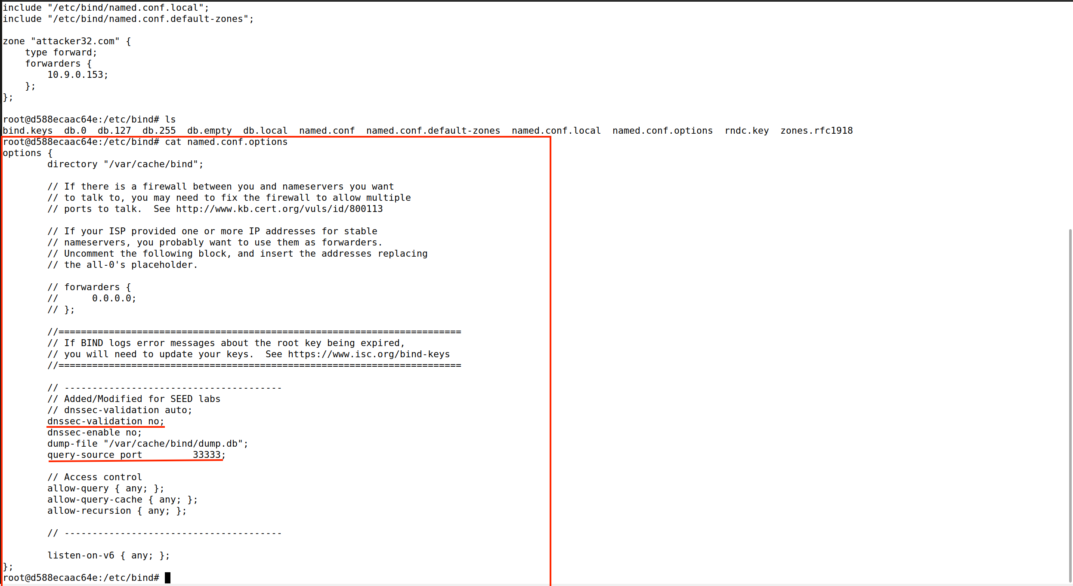

**DNS cache:** During the attack, we need to inspect the DNS cache on the local DNS server. The following two commands are related to DNS cache. The first command dumps the content of the cache to the file /var/cache/bind/dump.db, and the second command clears the cache.

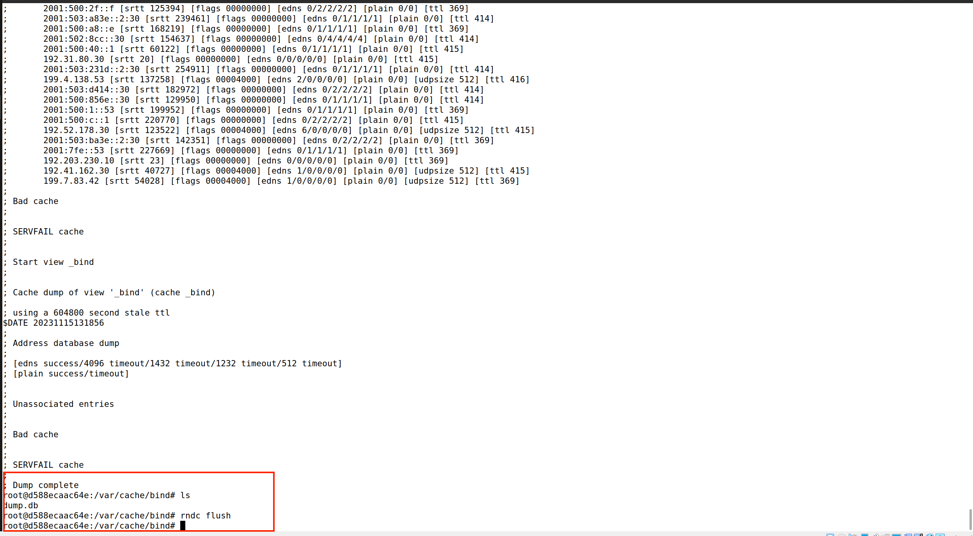

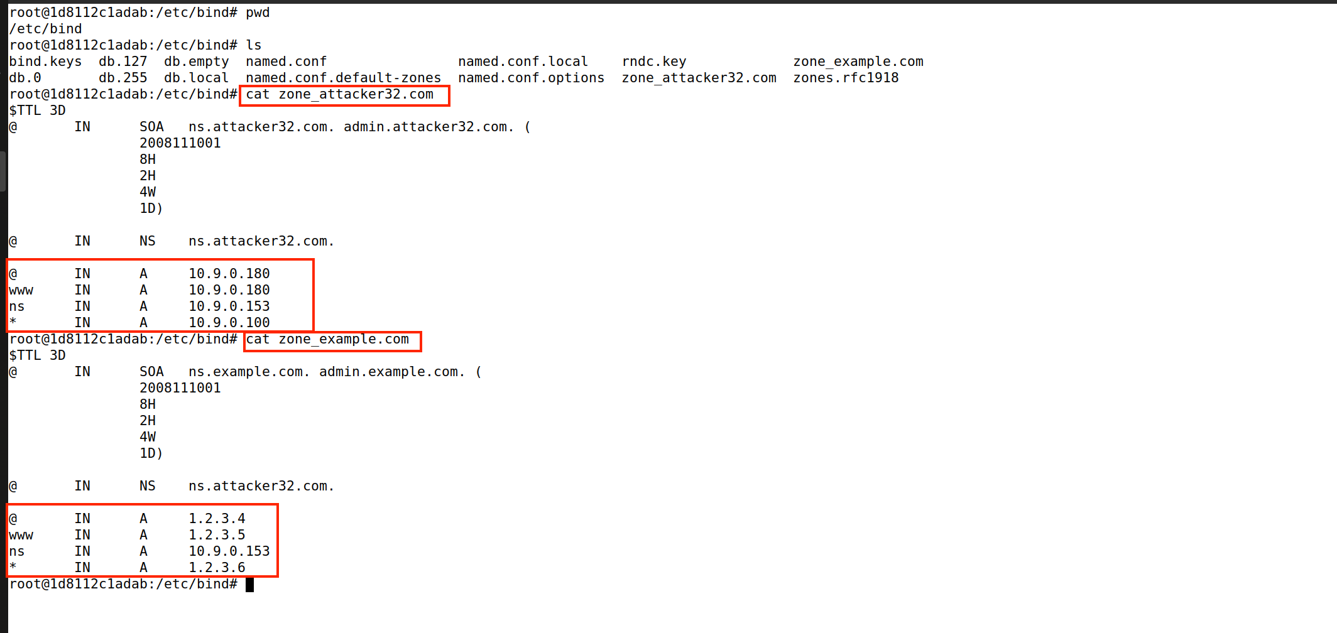

**Attacker’s Nameserver:** On the attacker’s nameserver, we host two zones. One is the attacker’s legitimate zone attacker32.com, and the other is the fake example.com zone. The zones are configured in /etc/bind/named.conf:

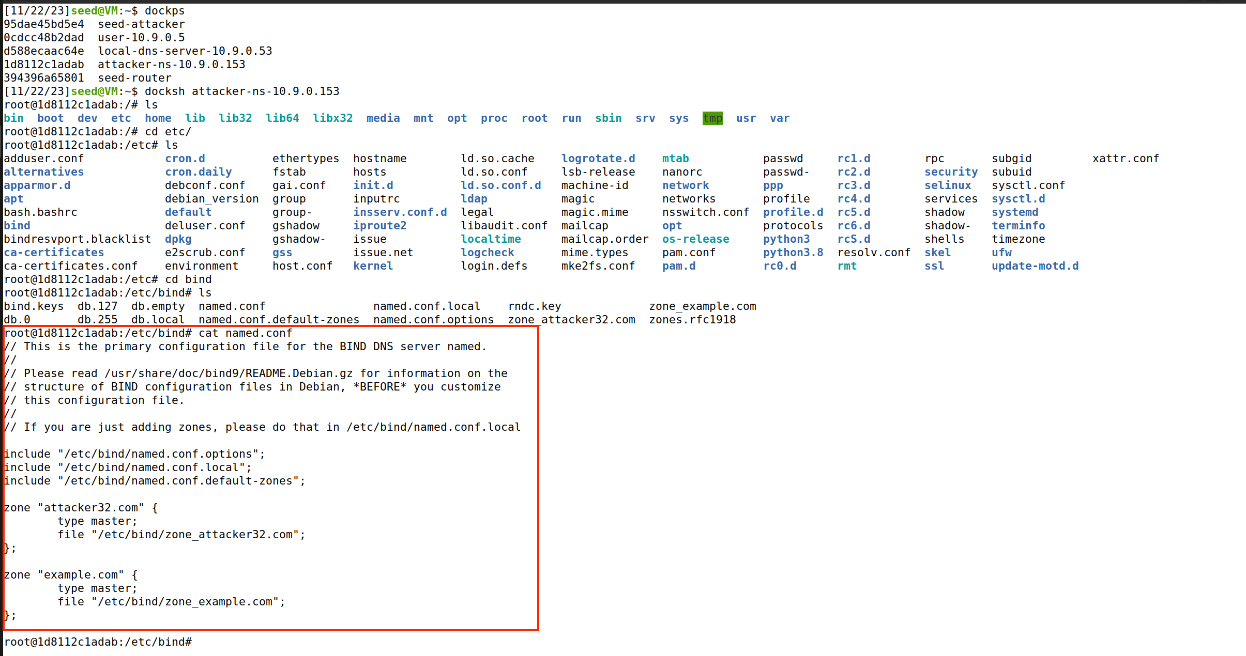

**User machine:** The user container 10.9.0.5 is already configured to use 10.9.0.53 as its local DNS server. This is achieved by changing the resolver configuration file (/etc/resolv.conf) of the user machine, so the server 10.9.0.53 is added as the first nameserver entry in the file, i.e., this server will be used as the primary DNS server.

**Testing the DNS Setup**

From the User container, we will run a series of commands to ensure that our lab setup is correct. In your lab report, please document your testing results.

Get the IP address of ns.attacker32.com. When we run the following dig command, the local DNS server will forward the request to the Attacker nameserver due to the forward zone entry added to the local DNS server’s configuration file. Therefore, the answer should come from the zone file (attacker32.com.zone) that we set up on the Attacker nameserver. If this is not what you get, your setup has issues. Please describe your observation in your lab report.

Get the IP address of www.example.com. Two nameservers are now hosting the example.com domain, one is the domain’s official nameserver, and the other is the Attacker container. We will query these two nameservers and see what response we will get. Please run the following two commands (from the User machine) and describe your observation.

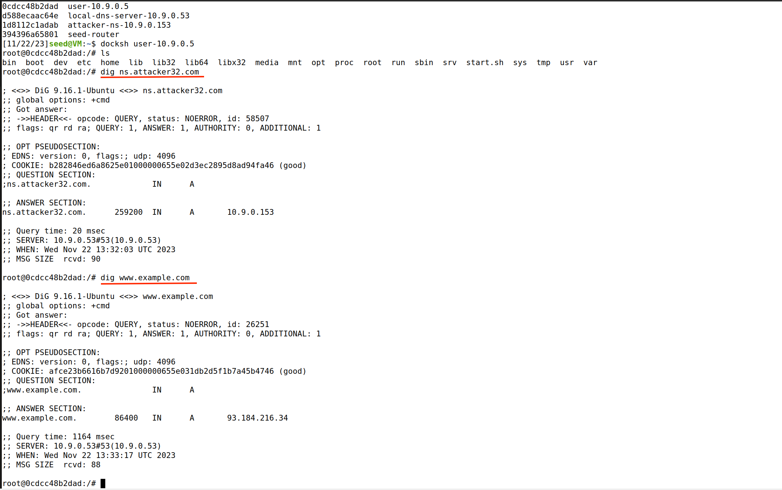

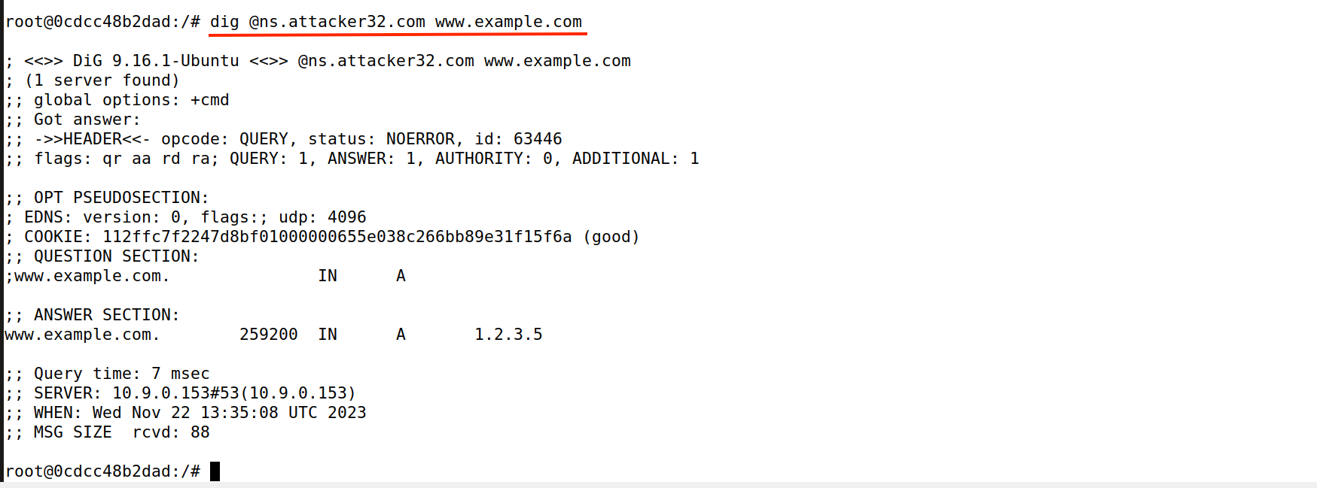

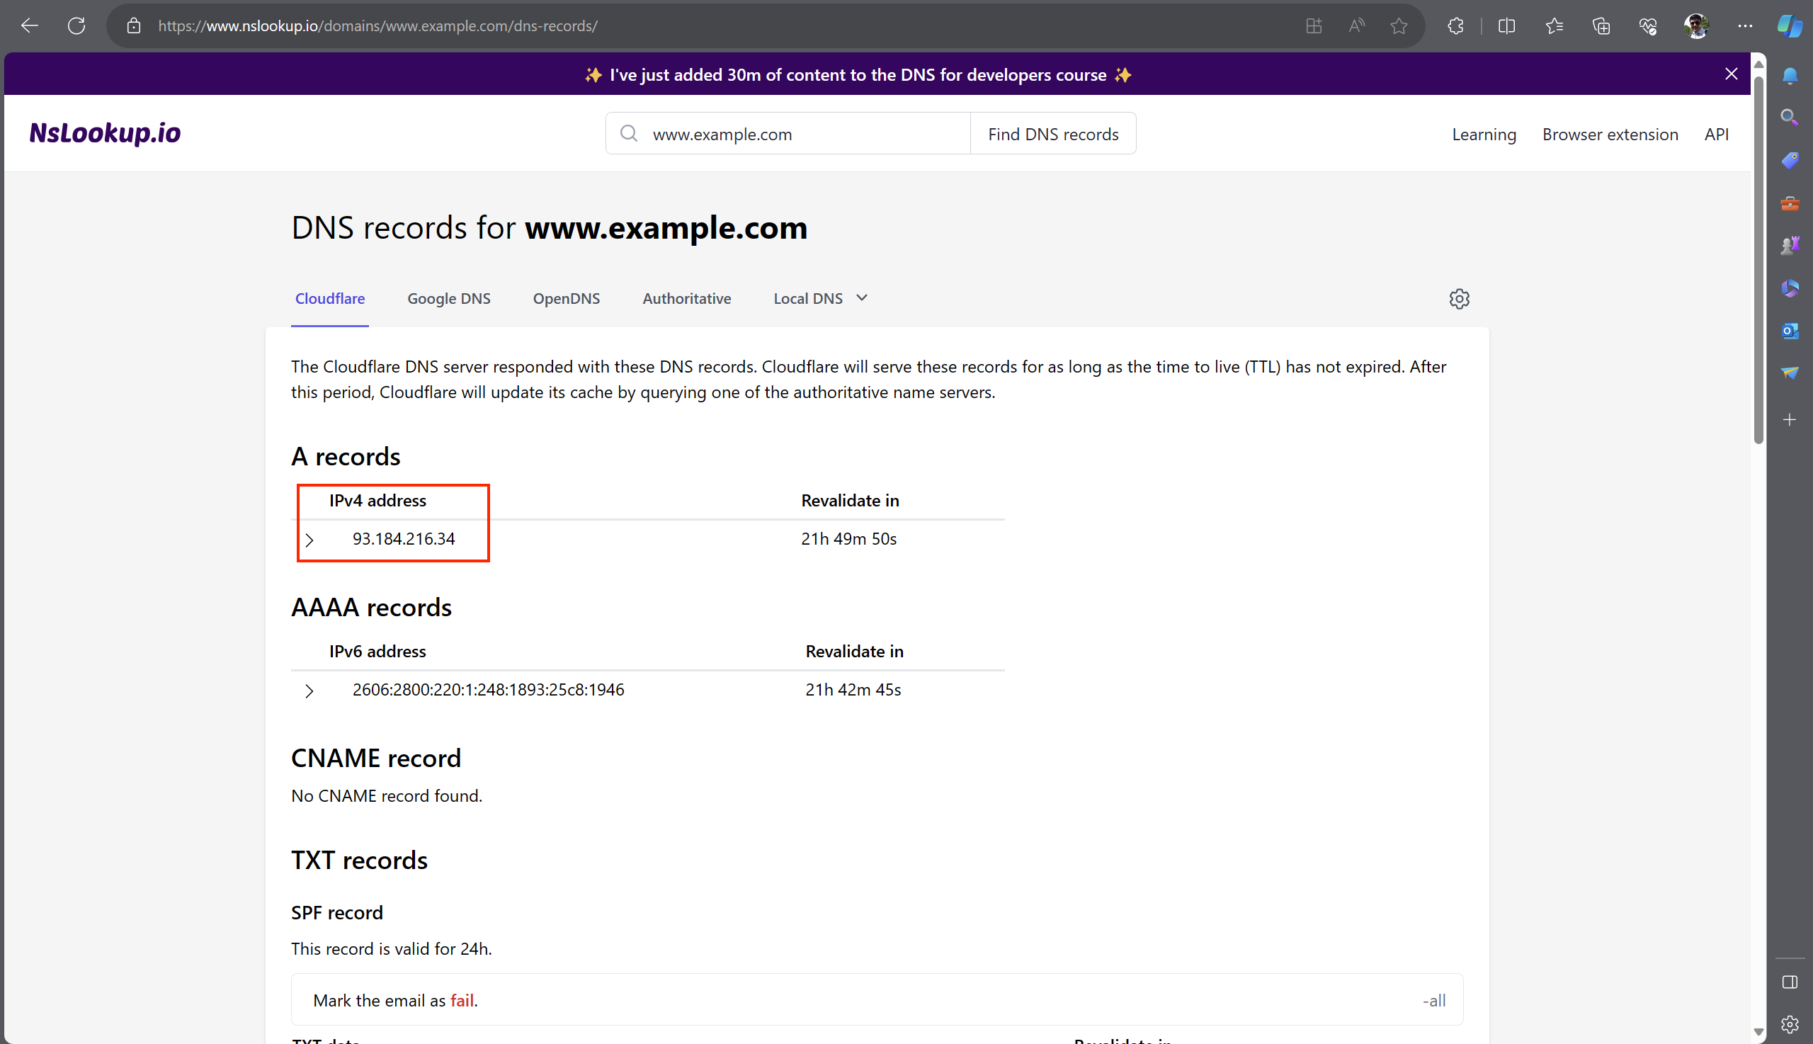

**The Attack Tasks**

The main objective of DNS attacks on a user is to redirect the user to another machine B when the user tries to get to machine A using A’s host name. For example, when the user tries to access the online banking, if the adversaries can redirect the user to a malicious web site that looks very much like the main web site of bank, the user might be fooled and give away password of his/her online banking account.

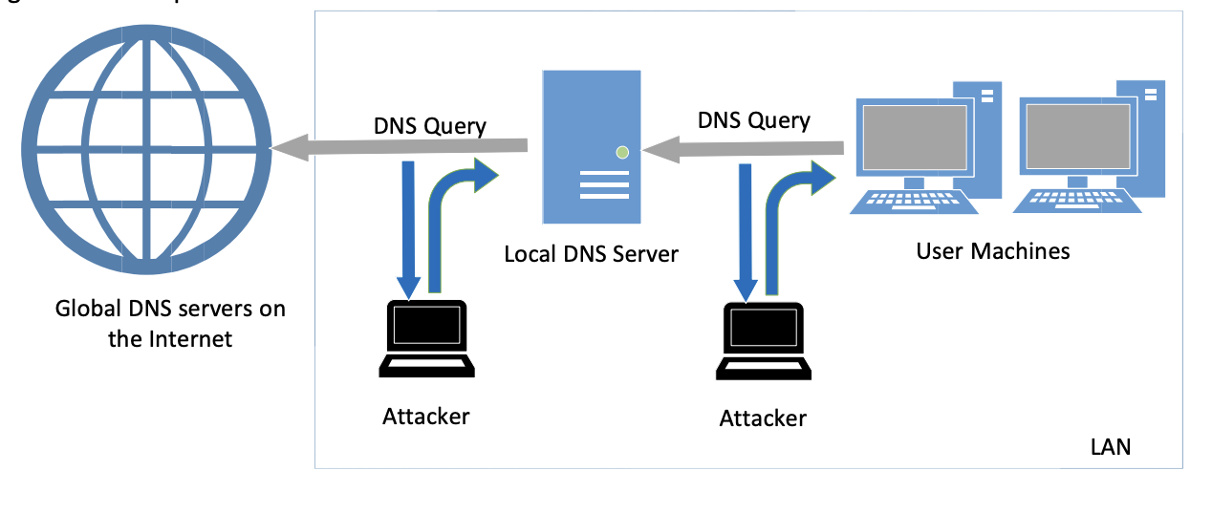

**Task 1: Directly Spoofing Response to User**

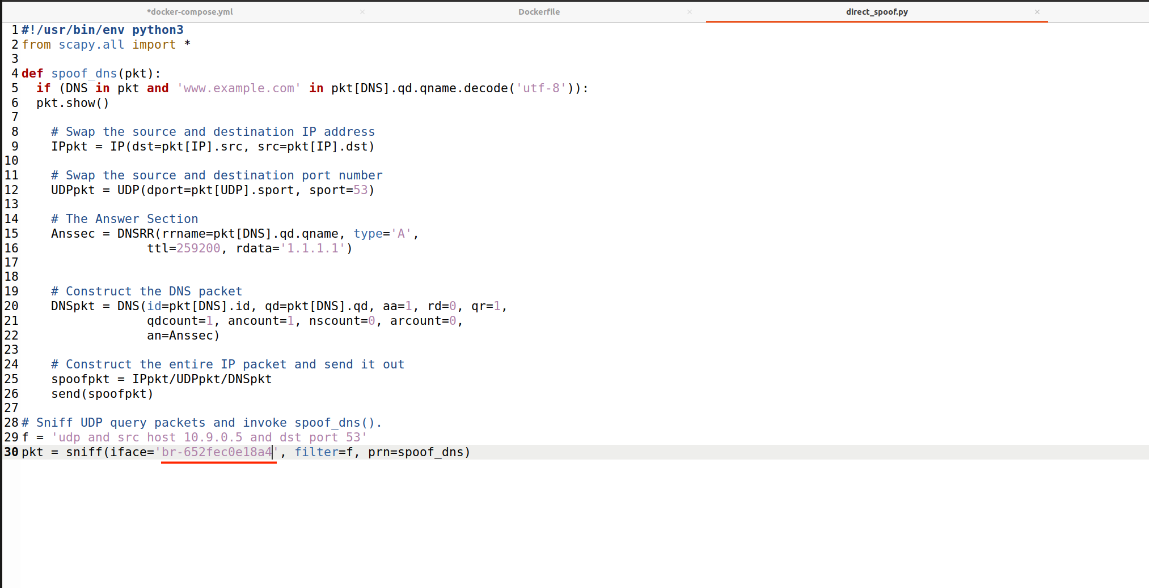

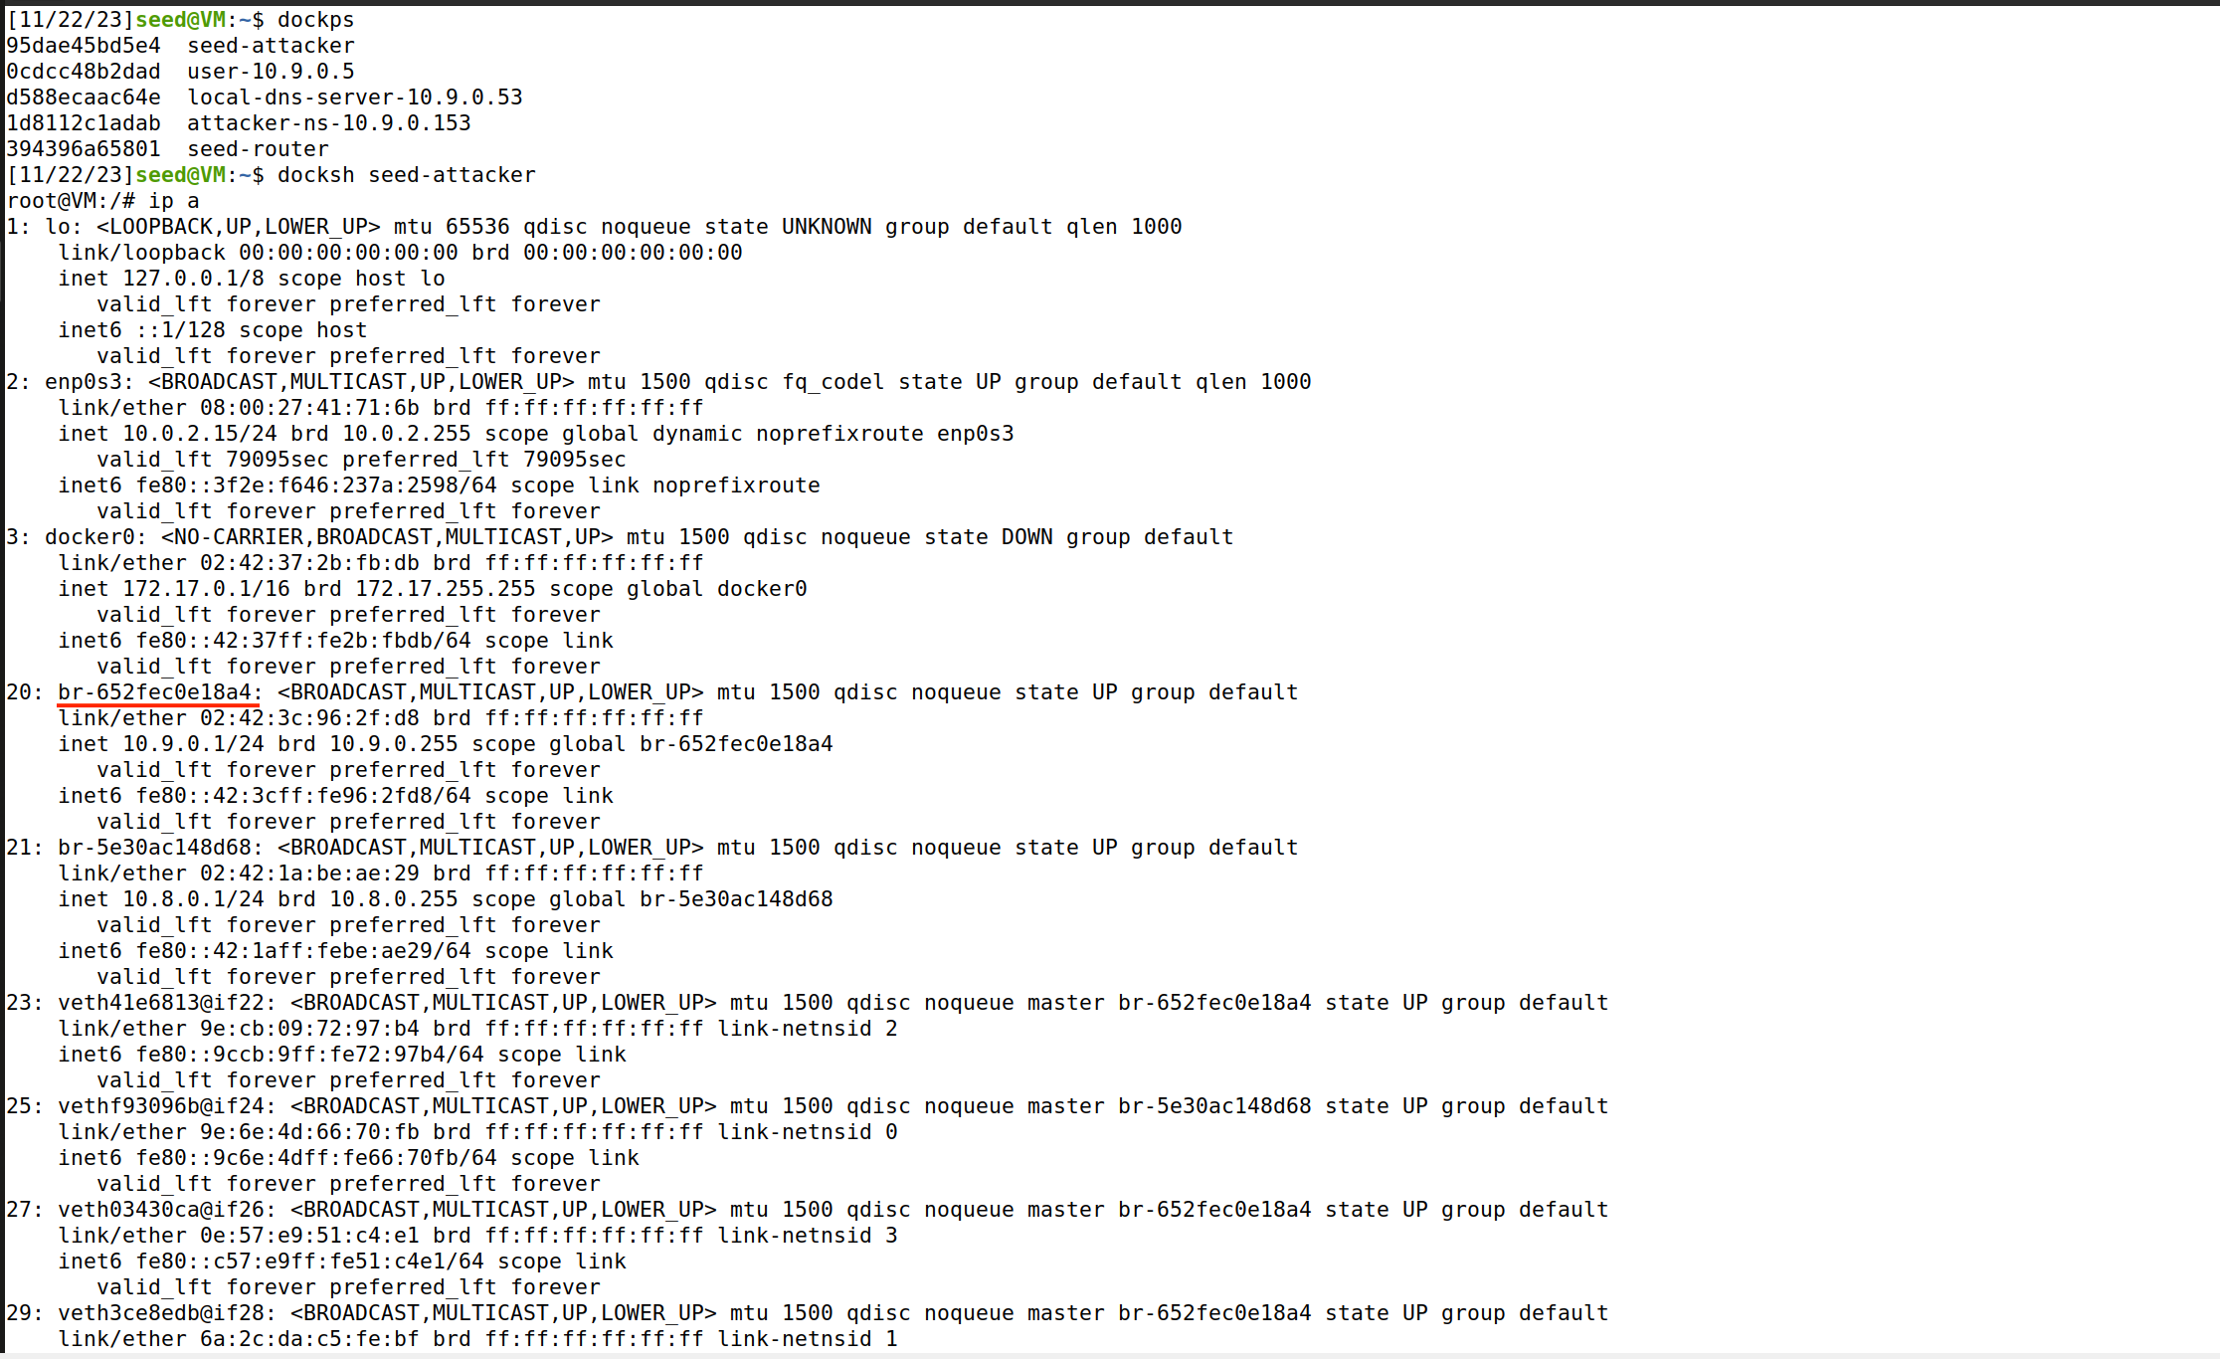

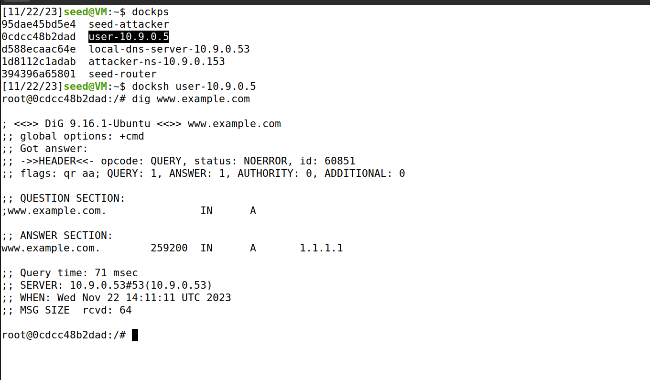

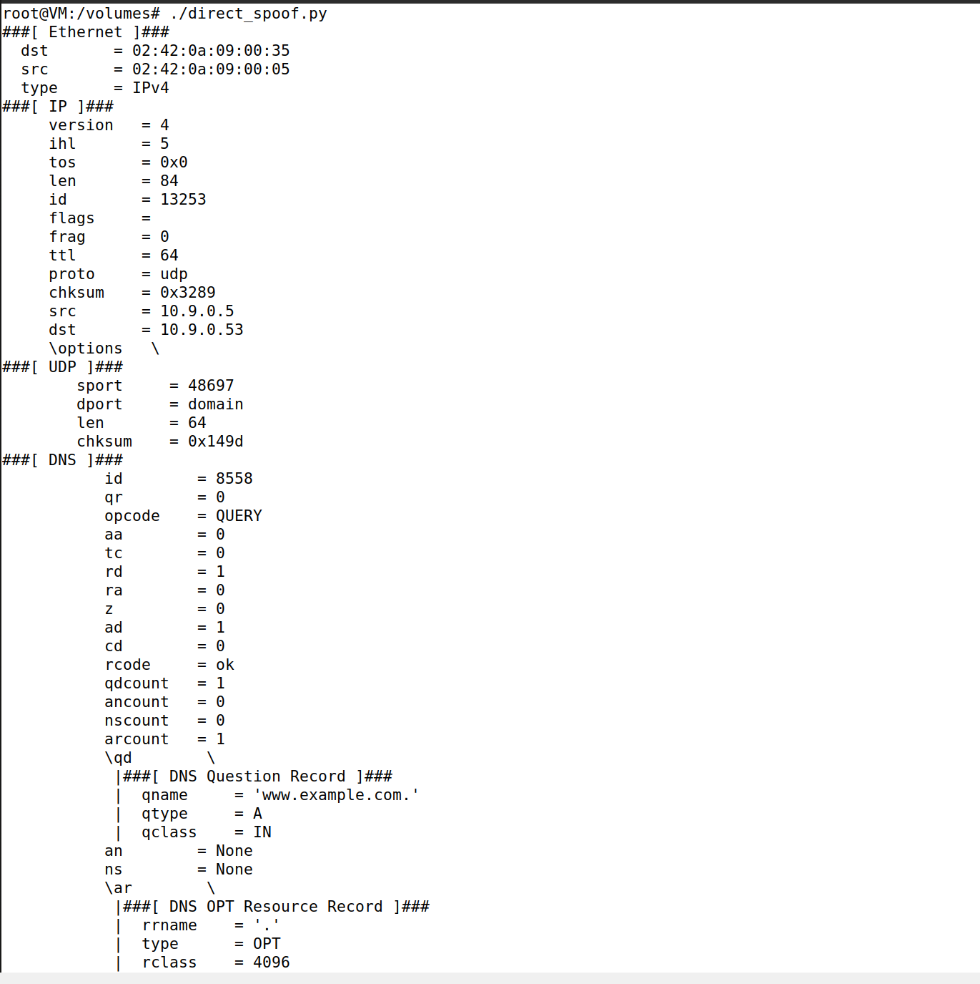

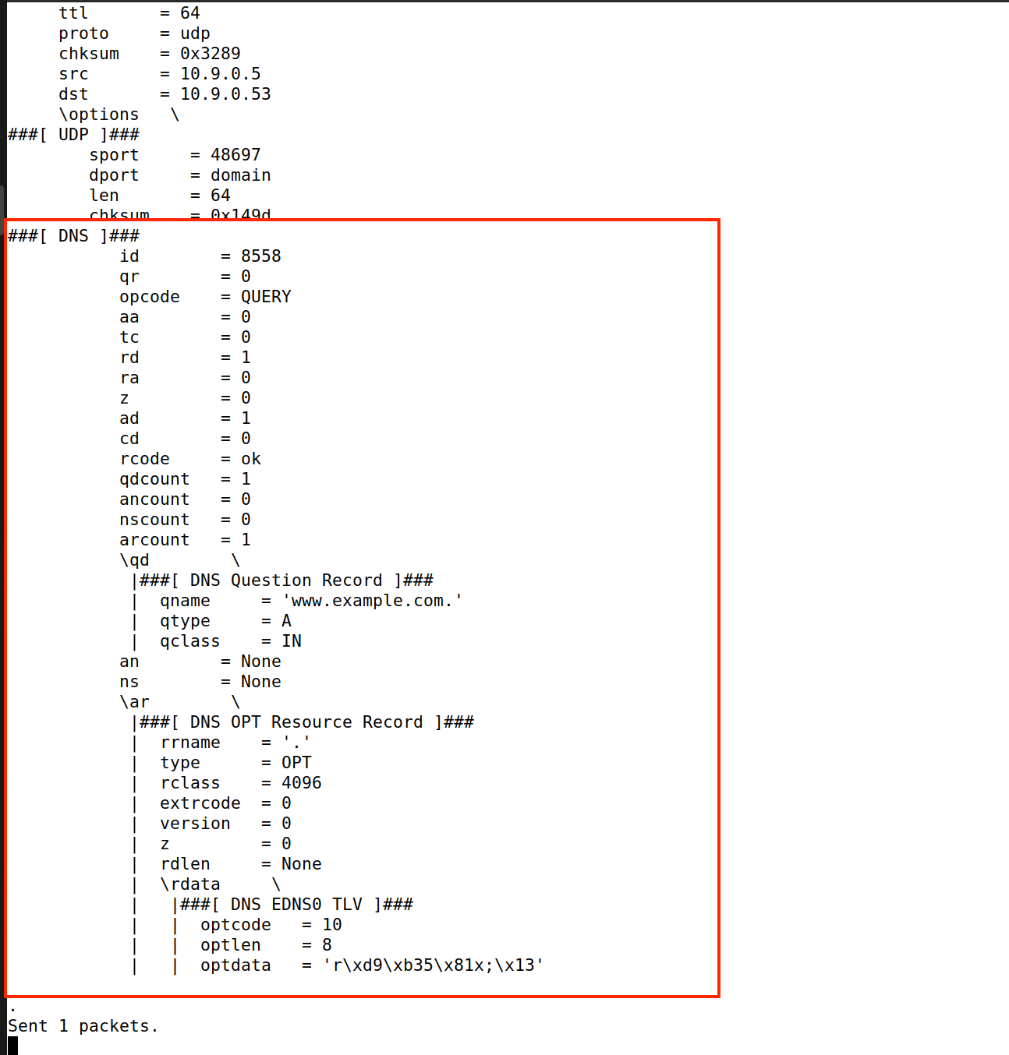



**Task 2: DNS Cache Poisoning Attack – Spoofing Answers**

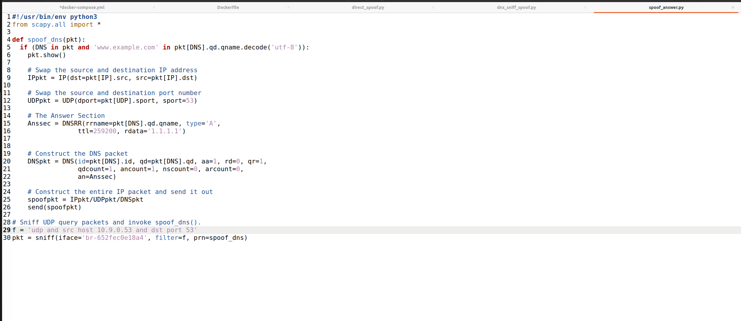

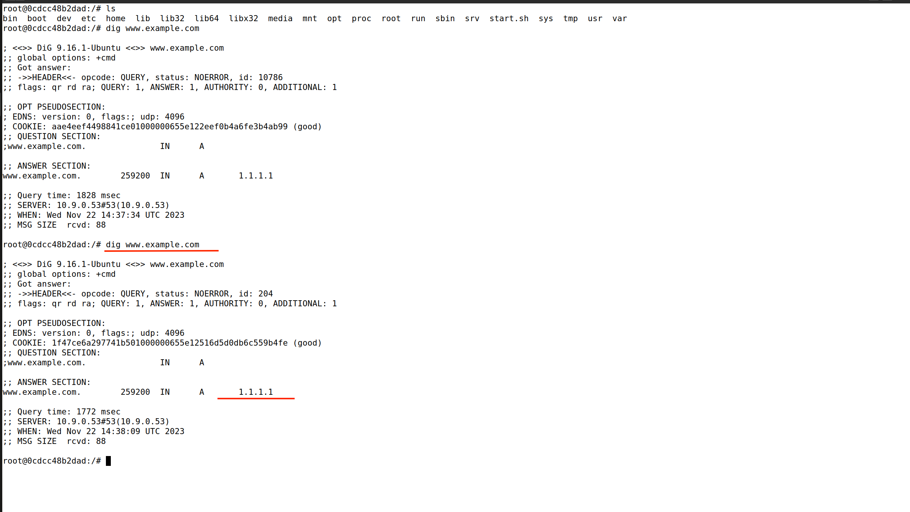

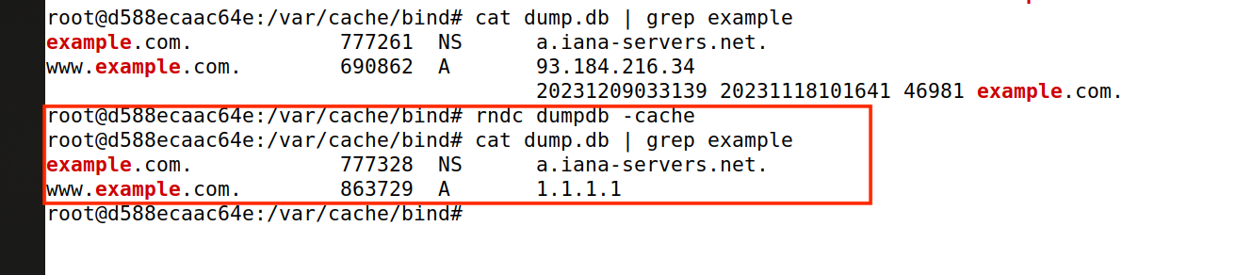

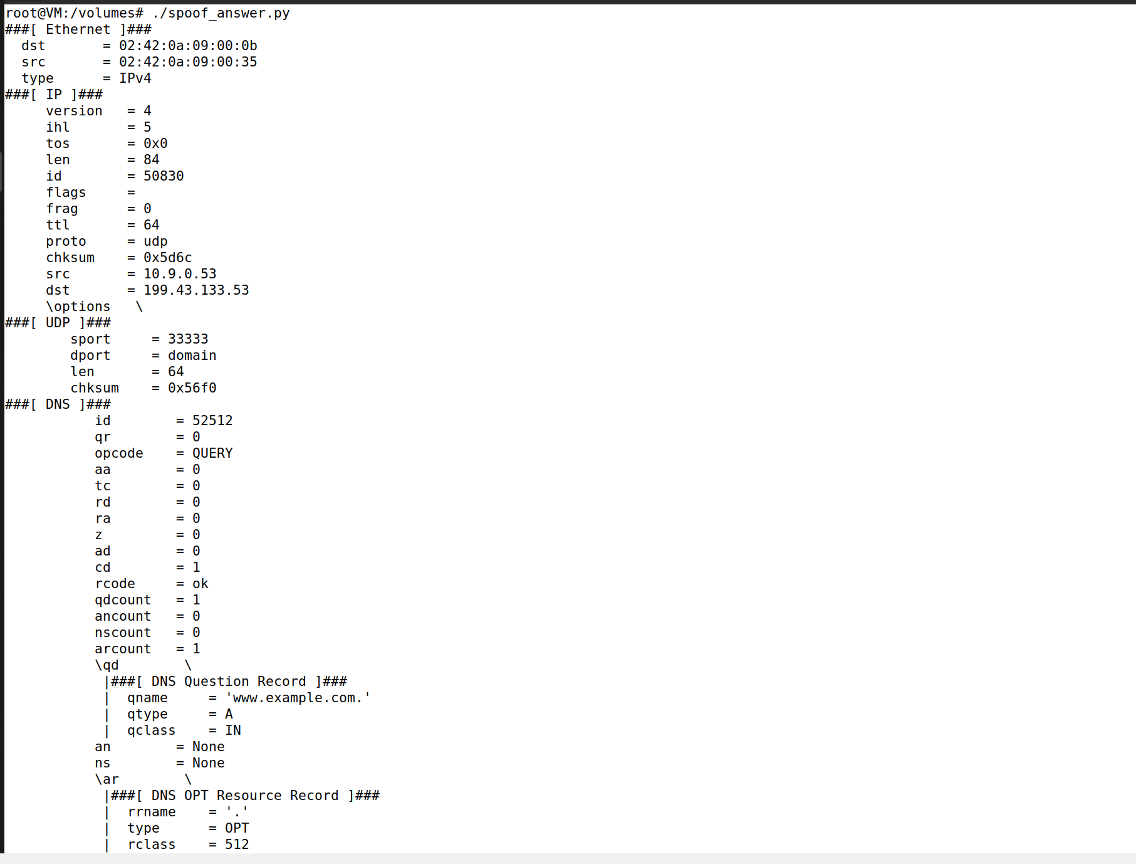

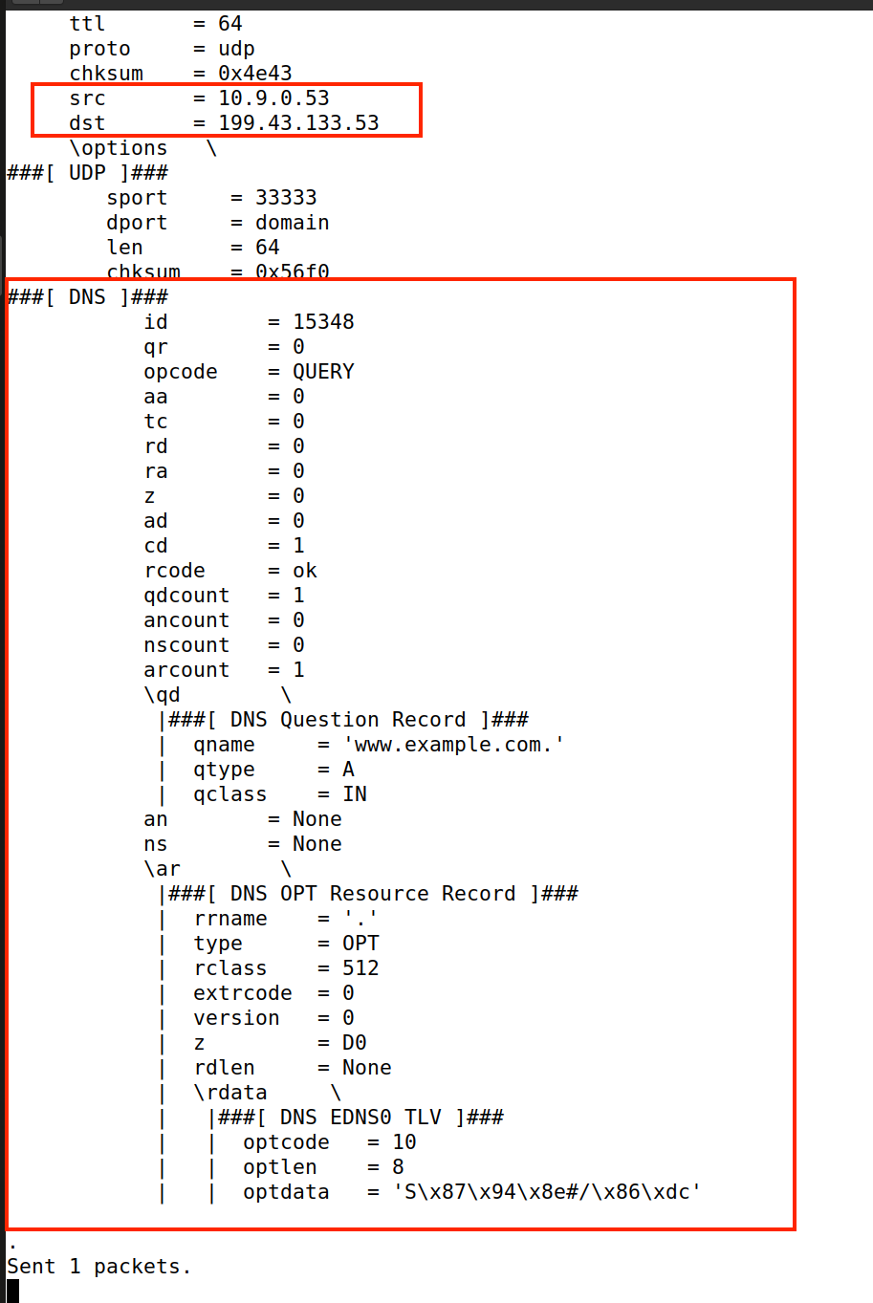

**Task 3: Spoofing NS Records**

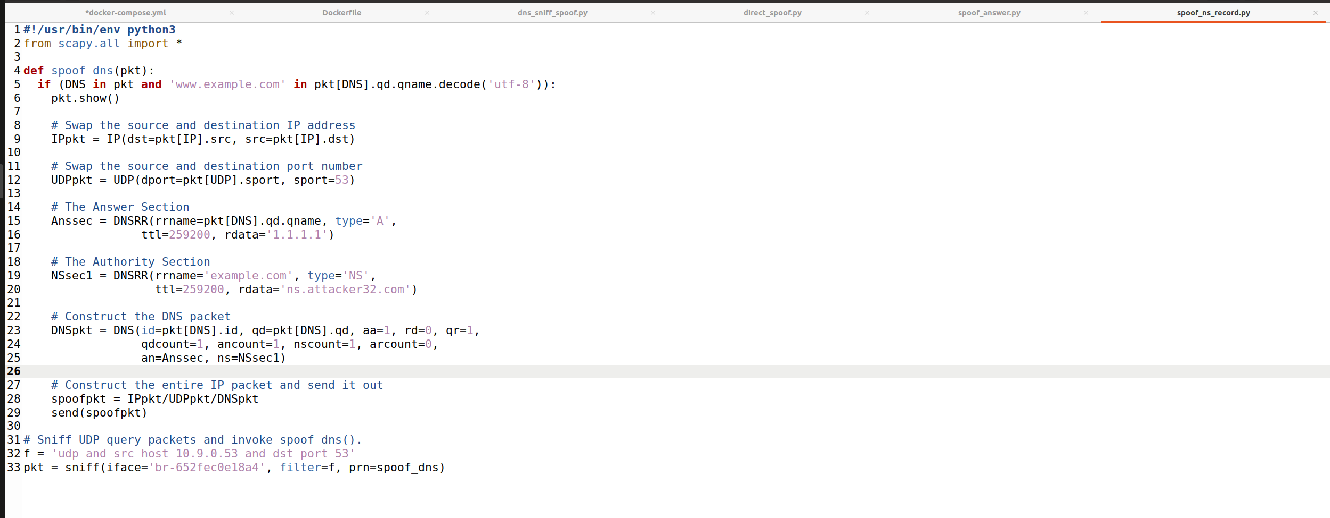

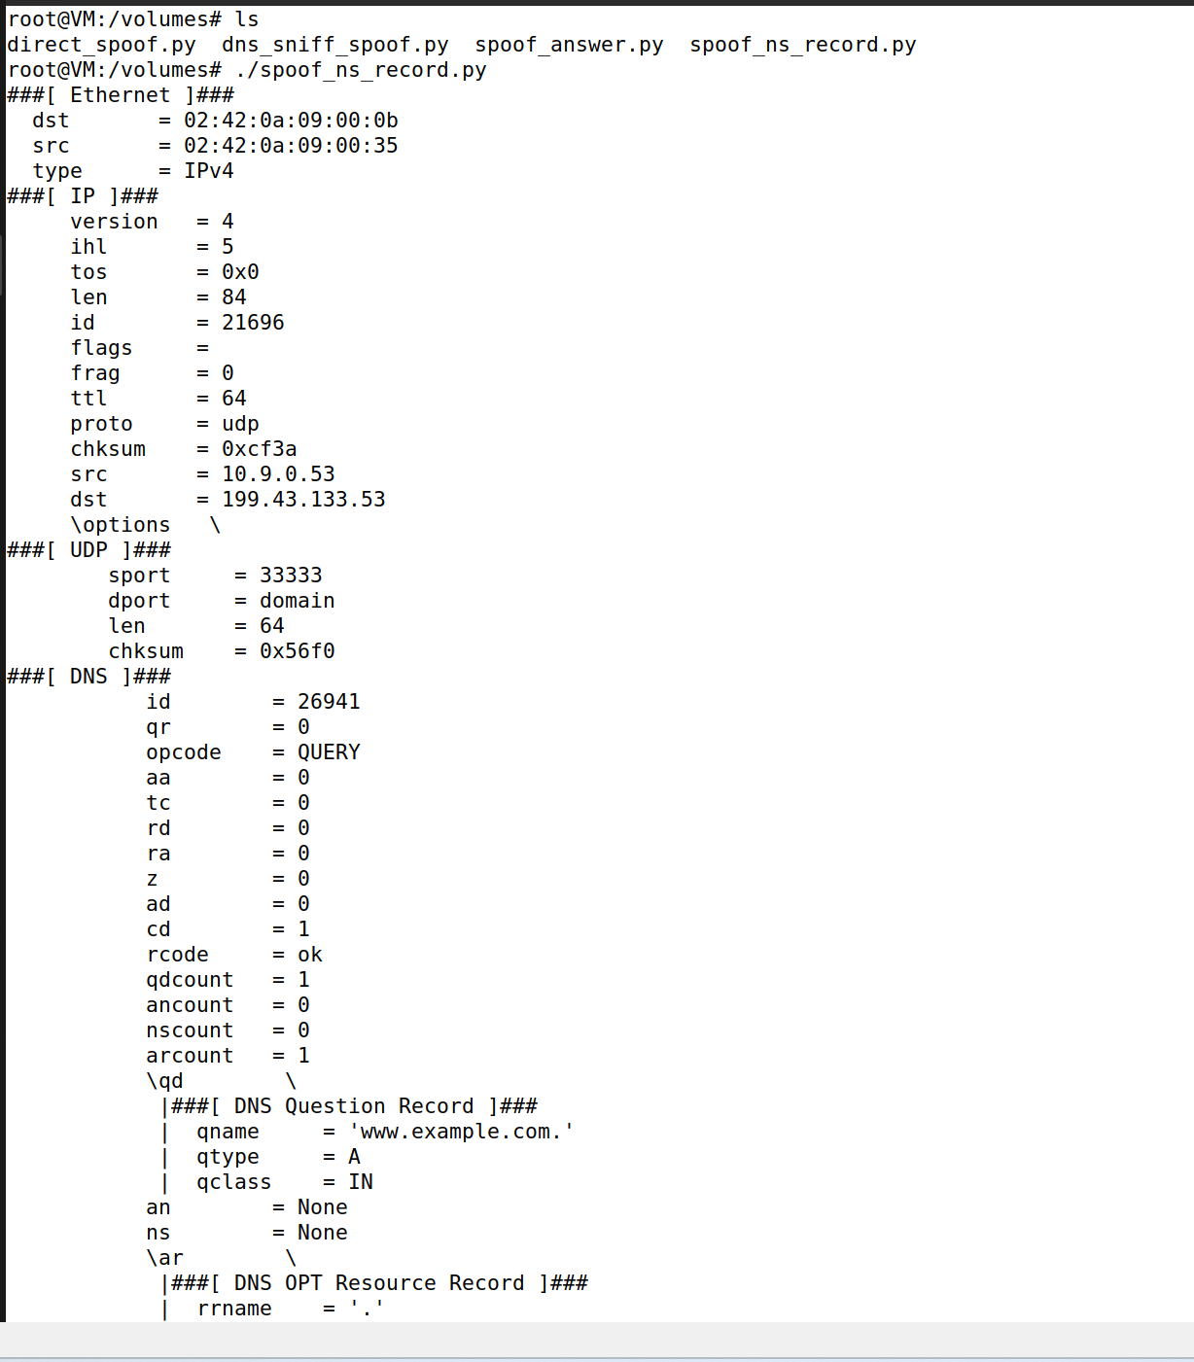

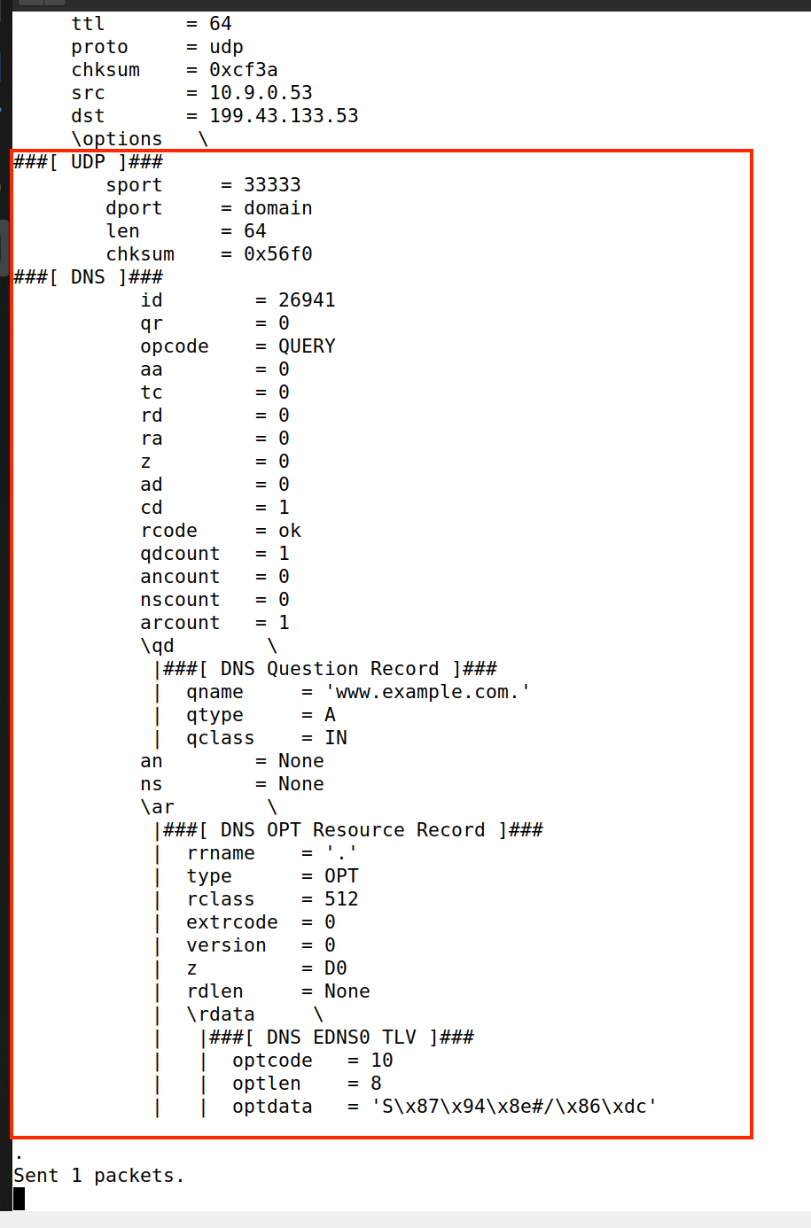

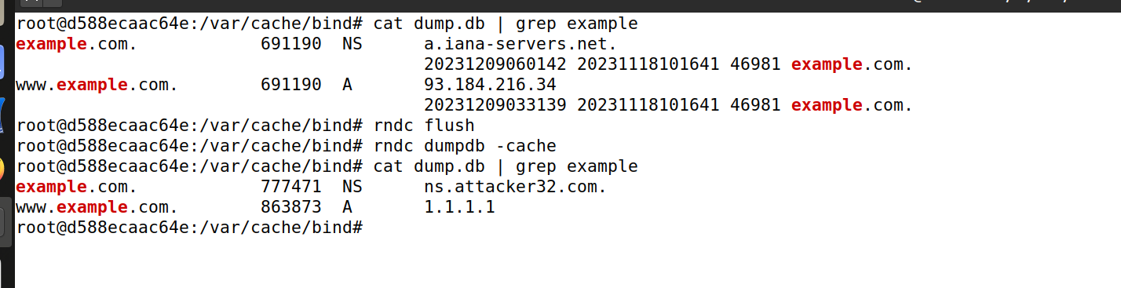

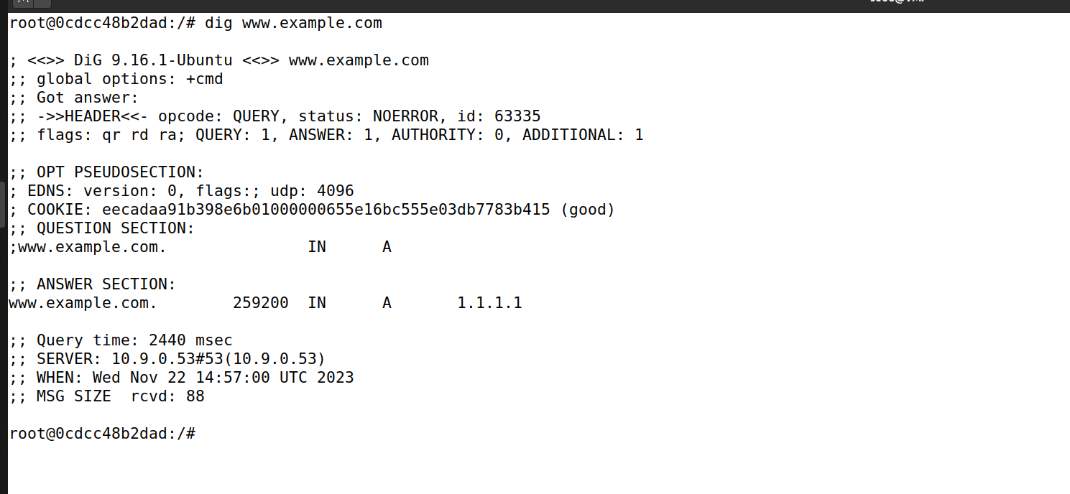

**Task 4: Spoofing NS Records for Another Domain**

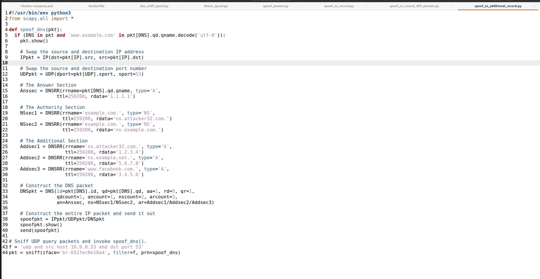

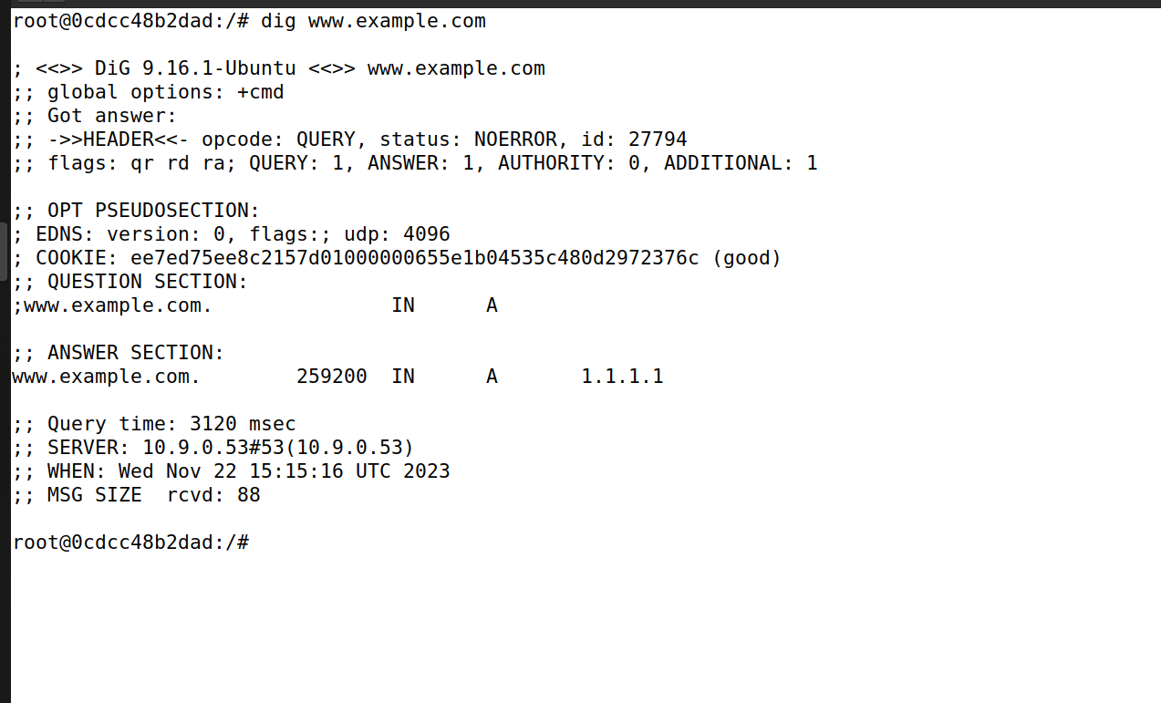



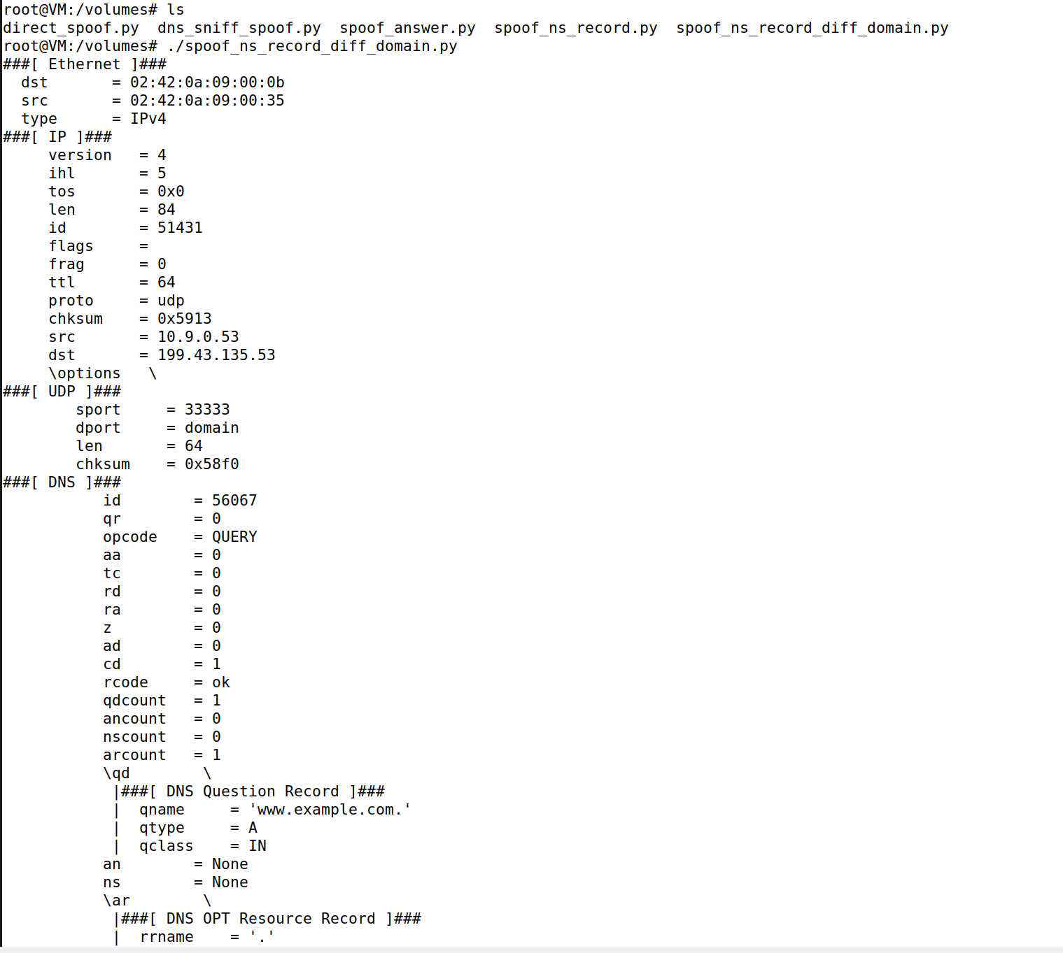

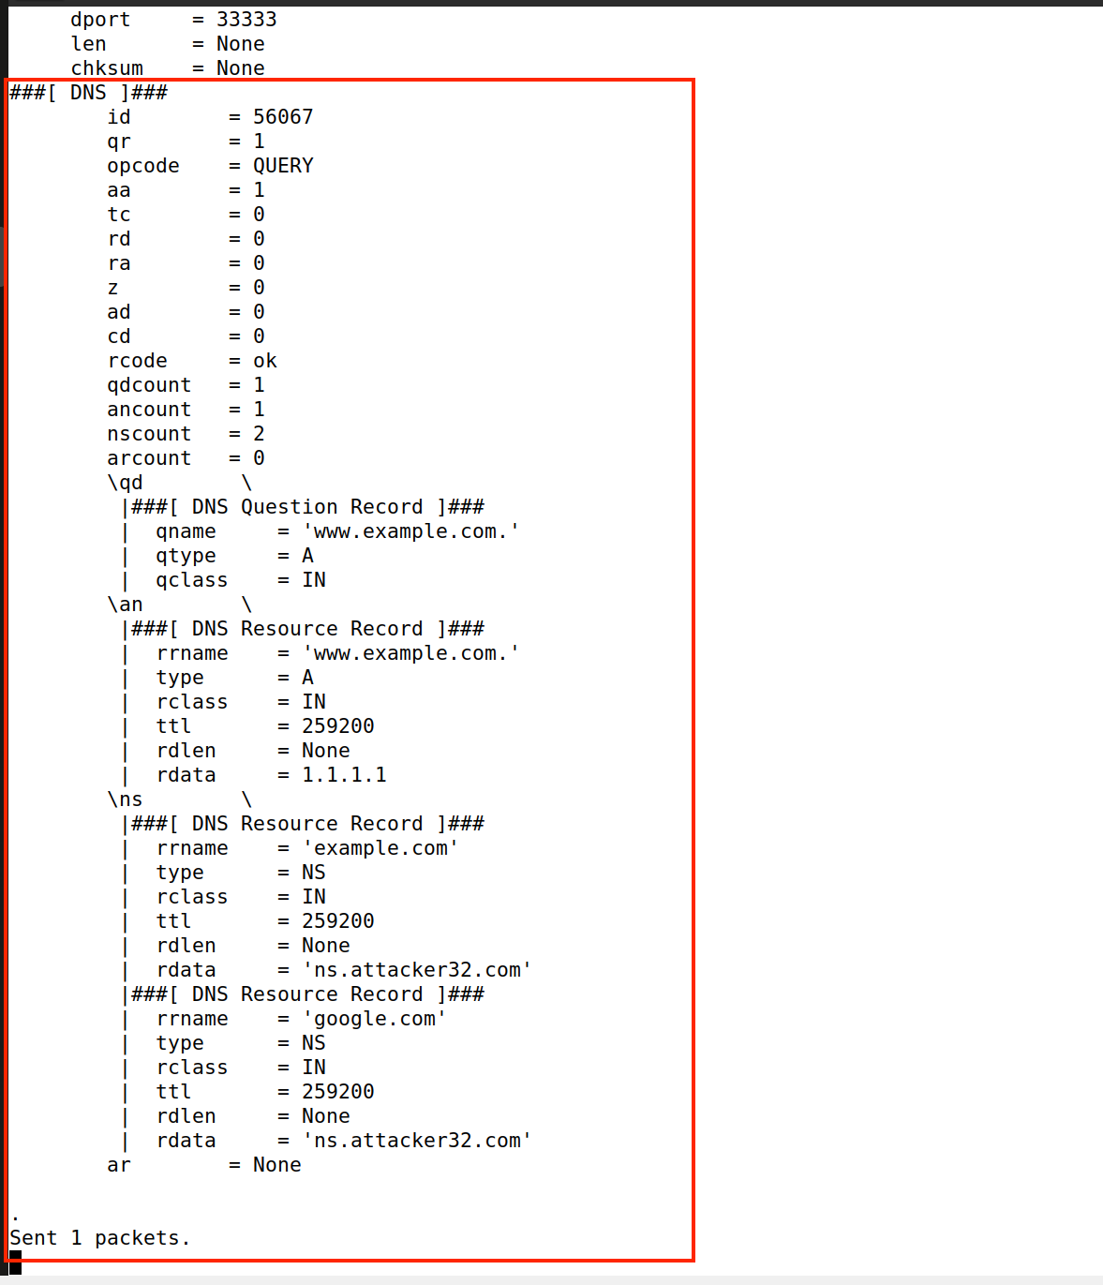

**Task 5: Spoofing Records in the Additional Section**



